Let’s Fly Design Document
Author(s): Sunjil Gahatraj
CST-451 Capstone Project Final Architecture & Design
Grand Canyon University
Instructor: Professor. Mark Reha
Revision: 1.0
Date:11/11/18

Design Planning Summary
This is an airlines reservation site. Booking ticket over the internet has never been easy because of all the hidden charges and tricks. Travel site are very hard to navigate through and if the person does not know much about airlines ticketing, chances are he/she will end up paying much higher price than they should be. This application will solve that problem. The goal of the project is to develop a web application which is very simple to navigate through and offer airlines ticket in cheapest possible amount. It will take all the factors that determine the price of ticket into account and present best option to the customer.

History and Signoff Sheet
Change Record
Date | Author | Revision Notes
11/09/2018 | Sunjil Gahatraj | Decided to drop Bitcoin Payment from the application because of lack of SandBox environment and API services
11/11/2018 | Sunjil Gahatraj | Finished writing design document
12/09/2019 | Sunjil Gahatraj | Finished first milestone. Added forms and database to the project
1/15/2019 | Sunjil Gahatraj | Changed project to Maven Project, added N-Layer architect to the structure of application
1/25/2019 | Sunjil Gahatraj | Removed JavaScript date picker because it was causing problem while trying to pick two dates for two way search
2/11/2019 | Sunjil Gahatraj | Changed database from Derby to MySQL database. Added Payment page
3/3/2019 | Sunjil Gahatraj | Added cart system to application so that user can added flight and check out at the end.  Using session
3/3/2019 | Sunjil Gahatraj | Added PayPal payment system to the application
3/20/2019 | Sunjil Gahatraj | Bootstrap forms and footer
3/25/2019 | Sunjil Gahatraj | Deployed application in AWS
4/10/2019 | Sunjil Gahatraj | 1. Added functionality to add multiple flights in the cart  2. Added functionality to display select button on flight search result page to make sure user do not select more than 2 flights
4/13/2019 | Sunjil Gahatraj | 1. Added UserFlight model class  2. Added UserDataService and UserDataAccessInterface to handle user related query  3. Added method in Business service class to add user and flight information in database  4. Once user confirm the information, all the flights associated with user's name with flight information will be stored in database  5. Bootstrapred Flightsearch pages and search result page
4/14/2019 | Sunjil Gahatraj | 1. User can now search, select, add info, view summary, and buy ticket. End to end connectivity  2. Added JSTL if tag to hide purchase button until user confirm the summary  3. User can see their ticket info while filling out personal informatio. Added div in userDetail page to show selected flight detail

Overall Instructor Feedback/Comments

Overall Instructor Feedback/Comments
Integrated Instructor Feedback into Project Documentation
☒ Yes ☐ No

TABLE OF CONTENTS
Design Overview 4
Detailed High-Level Solution Design 5
Detailed Technical Design 6
Appendix A – Technical Issue and Risk Log 7
Appendix B – References 8
Appendix C – External Resources 9

Design Overview
This is the design document for the Let’s Fly airlines reservation site. This will act as the blue print for the development phase of the application. It contains logic diagram, physical diagrams, site map, UI diagram, deployment diagram, sequence diagram, database design and schema, ER diagram, UML diagram to help the developer to meet the application requirement. This can be used as reference during the development to make sure everything is going on as planned. Some of the feature this document will help achieve are:

- Expedite the development process
- Narrow down the requirement so that developer can focus on solving important issue
- Understand the sequence of different process within the application
- Understand the flow of application
- Limitation and strength of application
- Design pattern used in the different part of the application
- Database type
- Cloud architect
- Third party application dependency
Detailed High-Level Solution Design
Deployment Diagram
This is the deployment diagram of the application. Application will be deployed in Azure cloud service and run on JVM. The container contains three runtime servers inside and it is a single tier architect. Apache Web Server is the web server, Tomcat Runtime Server is the application server and MySQL server is the database base. Client and payment portal access the application via internet.

Use the templates below to list the Proof of Concepts, hardware, and software technologies.

Proof of Concepts
Description | Rational
- PayPal integration | PayPal is the only payment service used in the application. It is very important to get developer account set up and get the idea how to integrate in the application. In this POC, I created a simple form which POST amount to the PayPal Sandbox and deposit the amount to account using merchant email address.

Requirement: Payment Gateway to pay for the ticket.
Rational for POC: Using Payment Gateway (PayPal) for the first time. Initially I did not get approved for developer account therefore this POC is very important to make sure everything is in place to move forward
Solution: I started by singing up for PayPal developer account. This gives access to their Sandbox environment. Sandbox is the testing environment where developer can create fake PayPal accounts, create transition, add money to Merchant account, or simulate buyer. This provide great opportunity to get used to the system and know how things work.
To test by understanding, I created two buyers and two sellers accounts. And, created simple HTML page with form which POST the amount to the PayPal Sandbox which can be paid using fake seller account. The amount paid by buyers is directed the Merchant’s account by using email address. Therefore, Sandbox doesn’t allow duplicate user even though it is testing environment.
In my real application, I will be using simpler logic to implement the payment system, but I will be using my private key and public key constraint to keep transition secure rather than using email address which is more predictable. I will have business logic to handle the scenario where card gets declined and user does not have enough amount in the card.

This exercise provided great insight on how to setup developer account and implement all the features PayPal offer. Other parts of the application like redirecting payment, posting form through controller are the things we have been doing throughout the course therefore did not mentioned on this exercise.

- Login page
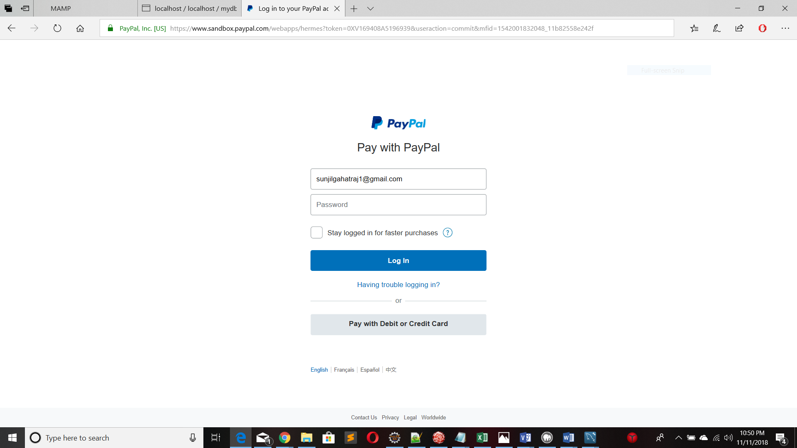

- I agree form
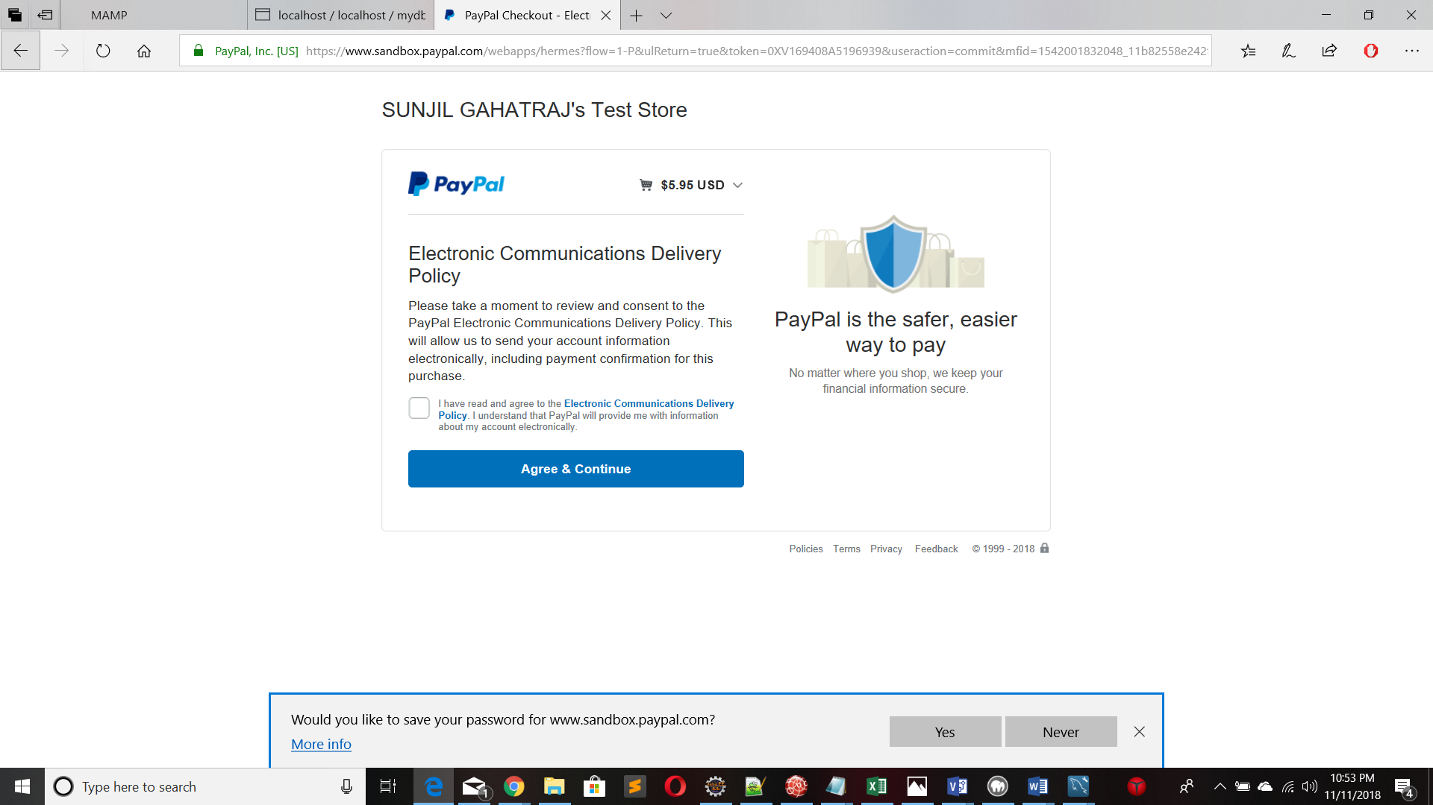
- Screen to select payment type
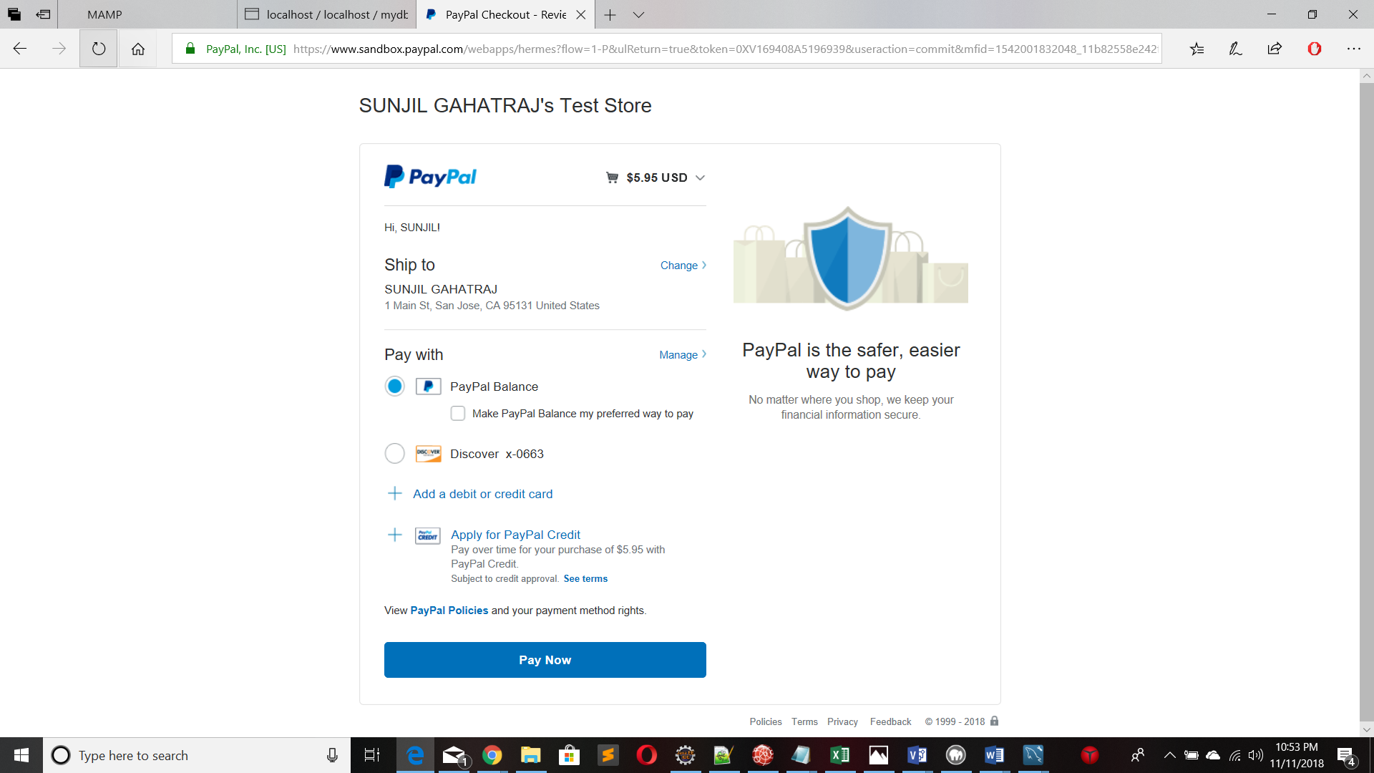

- Payment confirmation
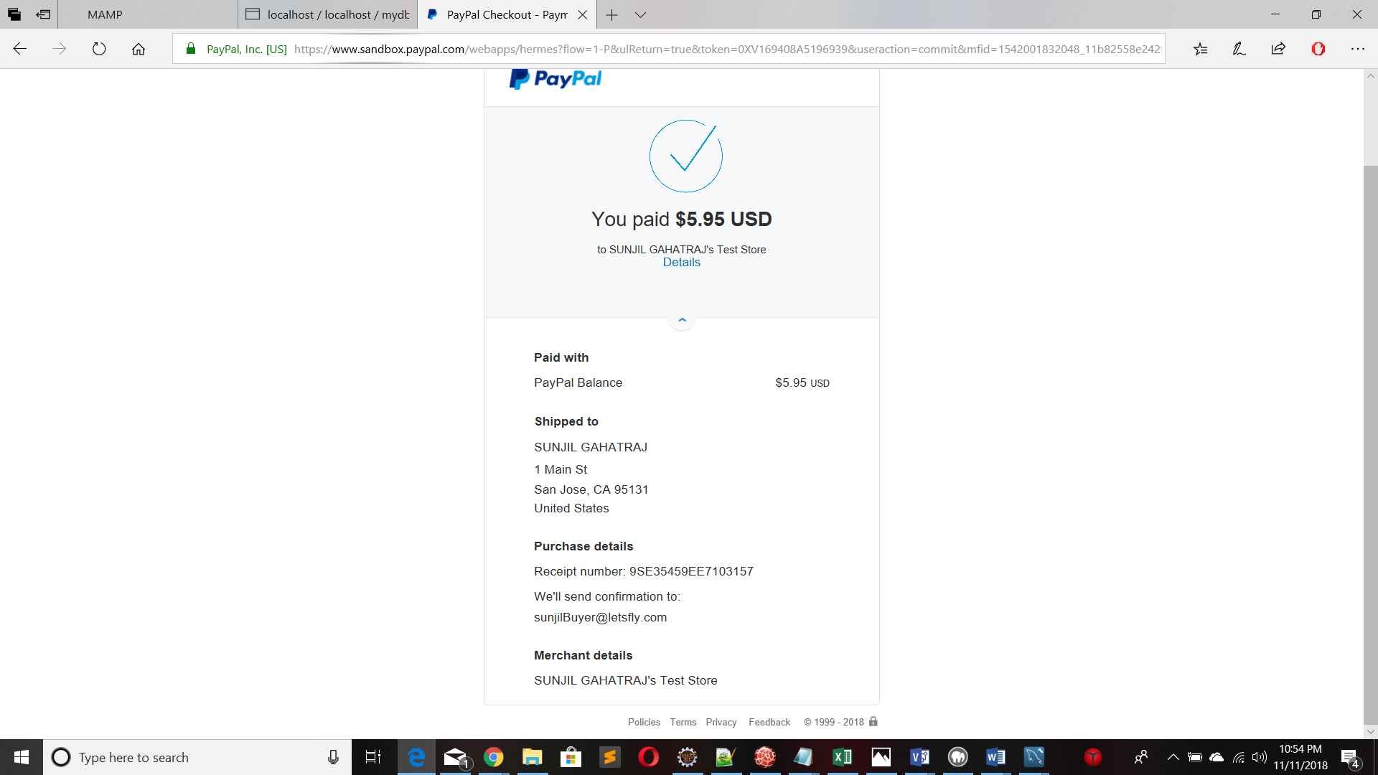

- Fake card info
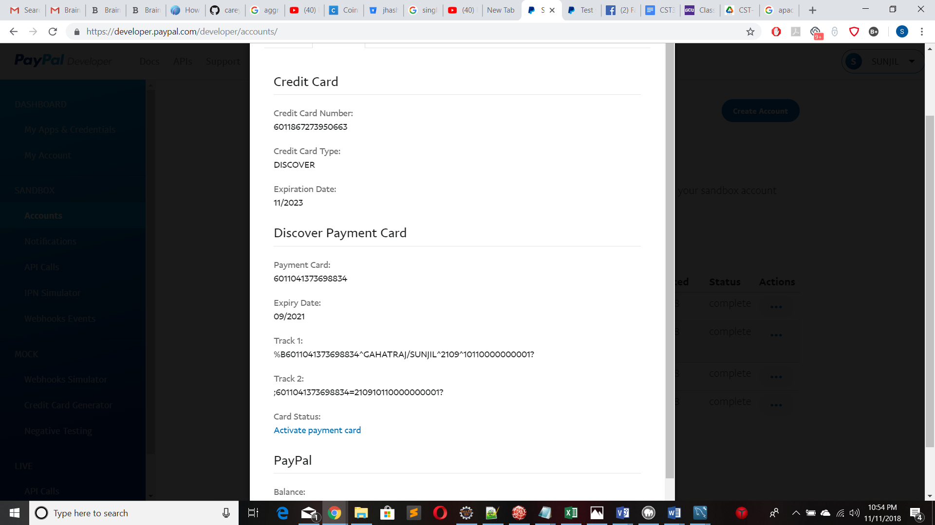

- Sandbox Dashboard
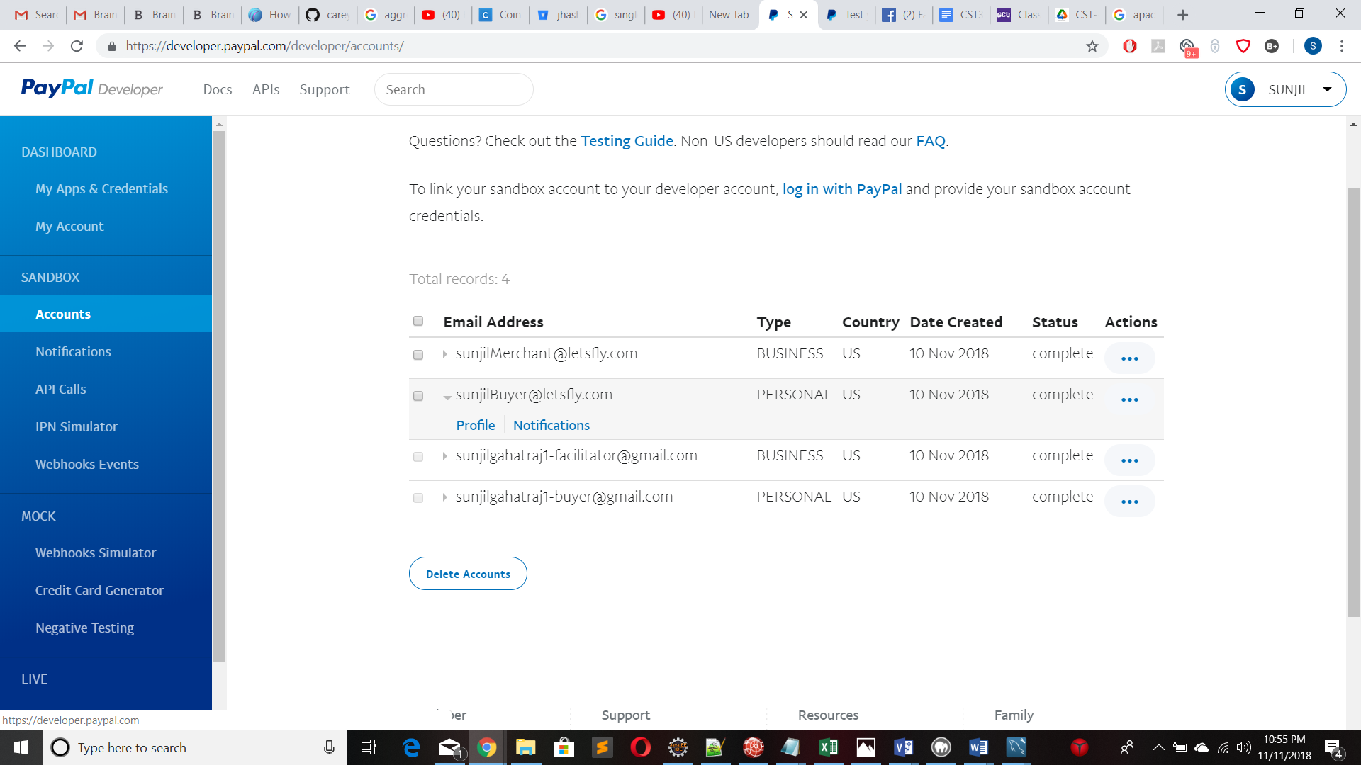

- Sample HTML form
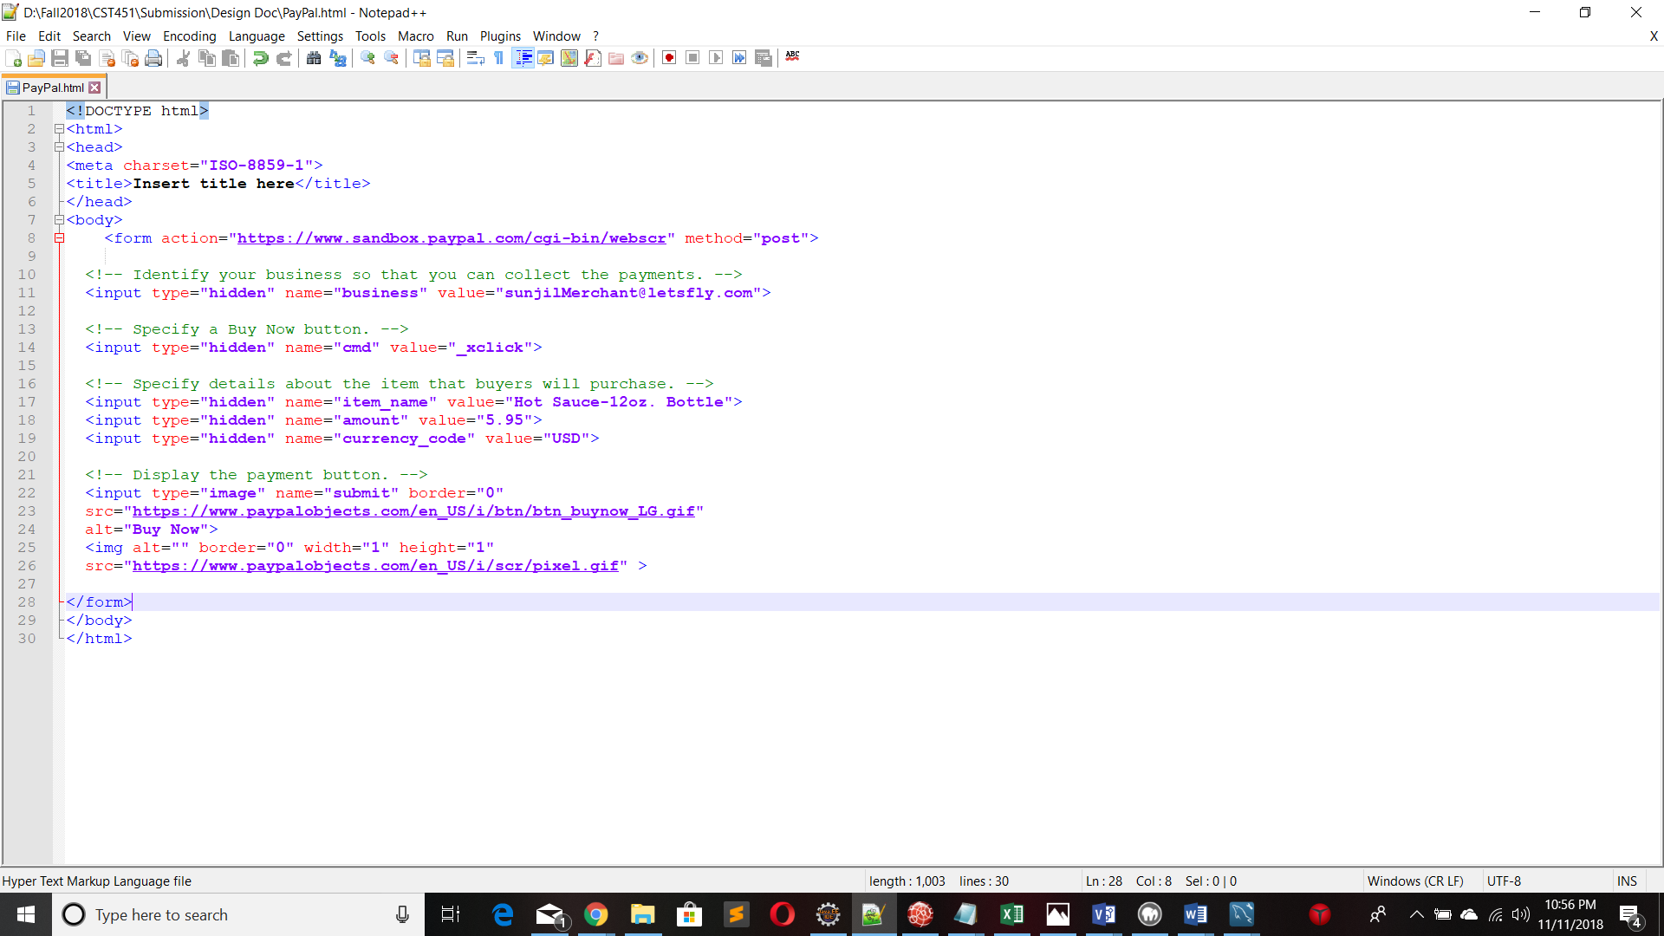

Hardware and Software Technologies
1 – Log4J
3 – BootStrap
4 – Spring Framework
5- AWS
6- Tomcat Server
7- Apache Web Server
8- MySQL server
9- Apache Tiles
10- MySQL database

Logical Solution Design

This is a high-level application logical solution design. It provides information about the logical structure of the application. As shown in the picture 1.1, program leverage the N- Layer architect design pattern. Application is divided into different layers based on the functionality. This makes code less dependable and more testing friendly and helps to create façade between user and technology used. Application used MySQL database to store all the data which is accessed through Data Access Object (DAO) in Data Access Layer. Moving up, all the business layer is the layer which contain all the algorithm and logic of the application. Second from the top in the picture is presentation layer. This is the most exposed part of the application. It contains technology that supports User Interface (UI). And, client layer is the top layer which represent the user side of the application.

Application Logical Solution

This is the application level logical solution. This is the detail view of logical design mentioned above. It contains technology specific detain in each layer help understand the logic behind the application. Application will use JSP pages and Apache tiles template framework in the presentation layer. It will also lever technology like JavaScript, Ajax, Bootstrap to make more user friendly and interactive. Business layer will have business classes to support Passenger, Flight, and Payment gateway’s business need. Data Access layer will have two DAO class to support Flight’s and Passenger’s functionality. All the methods in all classes and controller are monitored by Log4J logging framework.

Physical Solution Design

This diagram represents the physical architect of the application. Application is divided into three distinct layers based on their physical location. The part in the middle is the Azure cloud service where the application is hosted. It a single tier application means, all three components application server, web server, and database live in same container. Tomcat 8.5 Runtime is the application server, Apache Web Server is the web server, and database technology MySQL. Client will access application using HTTP request through internet. On the right side, there is third party support layer i.e PayPal gateway service. It is used as payment portal and accessed using HTTP request. As of right now application is using Sandbox environment for design and development process. It will be replaced with real account once application go live.

In the initial phase, to keep cost low, application will be powered by single core CPU and one gigabyte of RAM and is not scalable. Based on demand, this could change in future.

Detailed Technical Design
General Technical Approach
This is a airlines ticket reservation site with the goal to provide easy user experience in cheapest price possible. User will start their search by providing origin airport name, destination airport name, and the date of the flight. Based on the data, user will be presented several flights. Detail information can be viewed by clicking on the flight and ticket can be booked by clicking on “Book” button. This will redirect user to the page where they confirm the number of passenger and the page where user will enter their personal information and PayPal credential for payment. To finalize the payment, user will pay the amount using PayPal’s site and after the transition is completed, user we get their booking conformation.

Key Technical Design Decisions
- PayPal Payment Gateway: PayPal is one of the most popular payment systems in the world with millions of users. Instead of using multiple payment system from different type of credit card governing body like Mastercard, Visa, Discover PayPal bring them all together in one payment system. To cut down the cost and simply the application, PayPal is the only payment system supported by the application in its initial phase.
*POC in the first section of document
- Log4J logging framework: Once the application is live and running in the cloud, it very difficult to find and fix the bug because there is no counsel to see the stack trace. It is industry standard to incorporate logging framework within the application especially for enterprise level application. Log4J is one of the most powerful Java logging frameworks. It very easy and simple to implement and provide great value to the application.

Database ER Diagram
There are total three tables in the database of this application. Table FLIGHT is used to store flight information. Table FLIGHTANDCUSTOMER is used to store customer and their flight information.

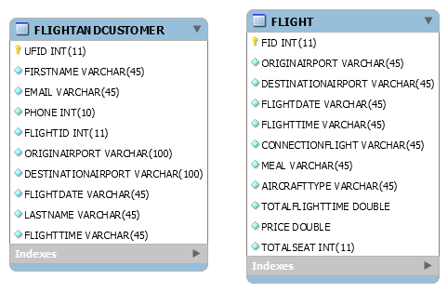

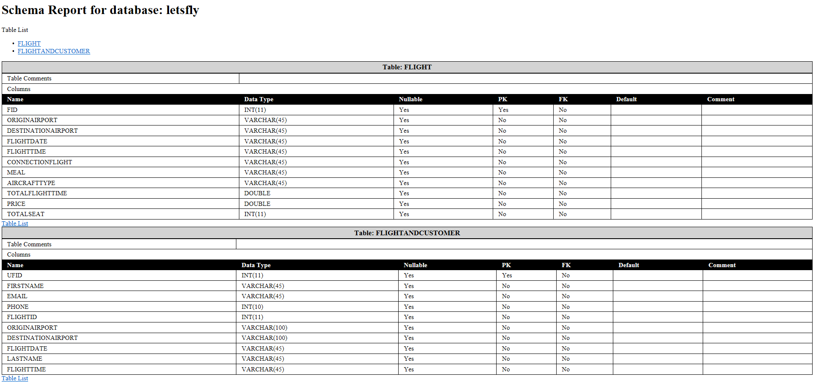

Data Dictionary

Flow Chart/ Process Flows

Application Flow

Sitemap Diagram:
User Interface Diagrams:

UML Diagrams:
- One way flight search

- Two-way flight search
- Search Result Page- two way
- Search result page-one way
4. Personal information
- Final Confirmation

UML diagram

Sequence Diagram
One way Flight Search
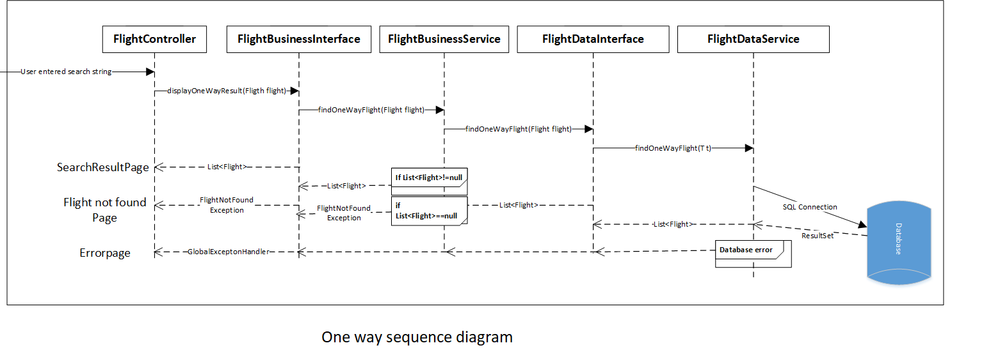

Two-way flight search

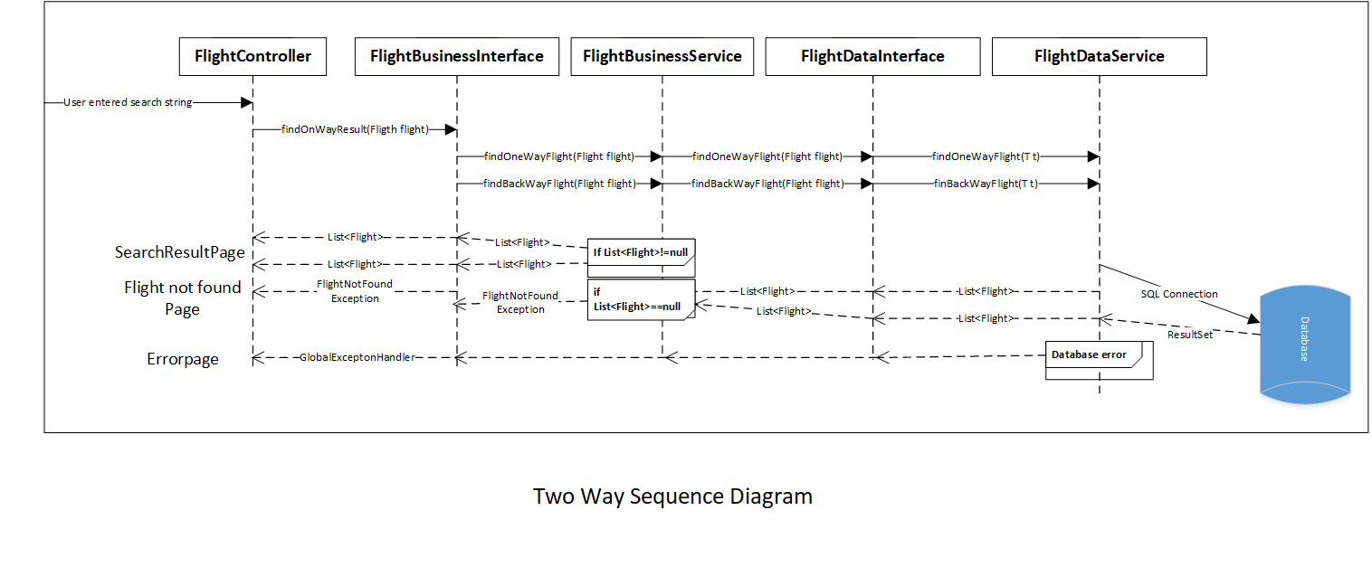

Service API Design:

PayPal Sandbox:

PayPal Sandbox will be used during the development and testing phase of the application. This is testing environment which acts and feel like real environment. Sandbox can be accessed and used using various method, one of them is using form POST. The total price of the ticket can be posted and passed along to the PayPal site which user can pay on the site. And once the transition is completed, application will trigger the final booking process and redirect user to conformation page.

Sandbox: https://www.sandbox.paypal.com/cgi-bin/webscr

NFR’s (Security Design, etc.):

- Backup: Azure offer excellent backup service in vey reasonable price. It cost $0.024 per GB for the first 1 terabyte (TB)/month to backup data using Locally Redundant Storage(LRS). Application data will be backed up in every 24 hours.

- Certification: Initially application will run without SSL certification and eventually certification will be purchased from Google.

- Disaster recovery: Backup feature will cover this functionality.

- Documentation: Development process will follow strict industry standard coding practice. Application will be full documented using Java Docs.

- Maintainability: Downtime is very less or almost none when application is deployed in cloud. According to Azure service agreement, application will have 99 % uptime per month.

- Performance: Application will be running in cloud with one core CPU and 1.75 GB RAM which is will produce enough power to handle 10 thousand request per month on its initial phase. As of right now Azure does not provide scalability feature in student account. Business license will be purchased to handle the growing traffic if required. Some of the feature static feature of the application will be developed using JavaScript and JQuery to cache the data and save server and database hit.

- Platform: Application will run without any difference in three main web browser i.e Google Chrome, FireFox, and Internet explorer. This feature will be achieved by using Bootstrap to make website responsive. Cross platform and cross browser are one of the main requirements of the application because of the growing mobile phone user.

- Testability: Application will be rigorously tested using Java testing framework JUnit. After development phase and before going into production, application will be put into test using test plan based on every possible scenario know till that point. Also, there will be small group of beta users to test application and in real world scenario. Application will be continuously updated based on their feedback and result from JUnit test.

Operational Support Design:
Logging and monitoring feature are very important for cloud application. It is the single most powerful tools for debugging and finding the bugs. This application will use Log4J framework to create application log.

Log4J is a reliable, fast and flexible Java Logging framework. It is an open source resource distrusted under Apace License. If offer different message types like TRACE, DEBUG, INFO, WARN, ERROR, FATAL, ALL also known as appenders, which can be used based on scenario.

Logger will be injected in all the methods in DAO classes, Business service classes, and controller. This will be designed to log the data only if something unexpected happens to save the storage.

Other Documentation:

User Case:
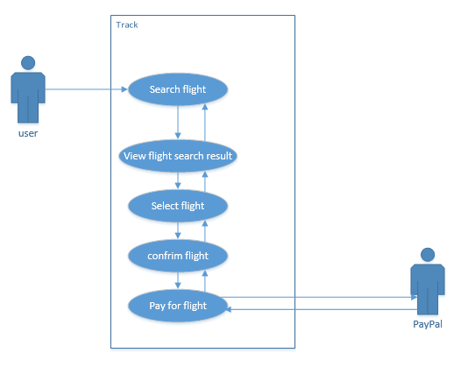
Let’s Fly

Resource:
Research : http://www.ai.mit.edu/courses/6.034f/psets/ps1/airtravel.pdf

